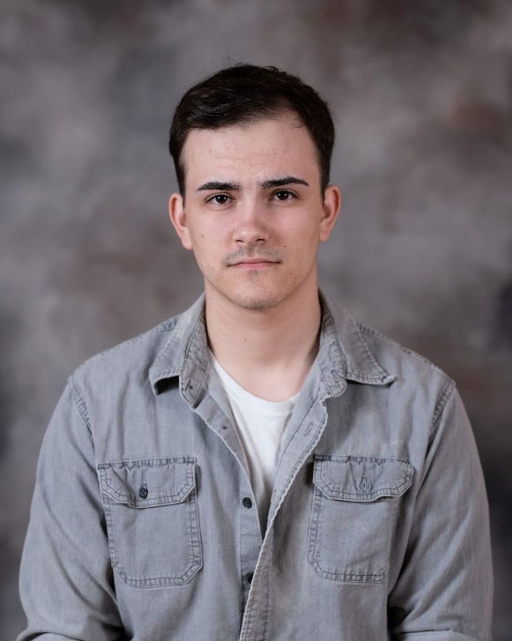Gunnar Carwile

Performer

**Height**: 6’1” **Eyes**: Brown **Hair**: Brown

[419-786-0409] | [gtcarwile@gmail.com]

# Acting Experience

***It’s a Small World of Robot Play –*** *Adam (2024)*

**-**Directed by Todd Dicken (Youngstown State University)

***Scapin –*** *Geronte (2023)*

**-**Directed by Todd Dicken (Youngstown State University)

***Antigone –*** *Creon King of Thebes (2023)*

**-**Directed by Todd Dicken (Youngstown State University)

***Puffs*** *– Ernie Mac, A Very Tall Man, Seamus, et al.* (2022)

– Directed by Todd Dicken (Youngstown State University)

# Trainings

SAFD A-Town Throwdown Workshop (2024)

Stage Combat (Teaching assistant/Quarter Staff) – Todd Dicken (2024)

Stage Combat – Todd Dicken (2022)

Austin Pendleton Masterclass (2021)

Bryan Terrell Clark Acting Masterclass (2020)

# Skills

Basic stage/Film combat, Basic Quarterstaff, Basic Knife handling, Swords (single, small, rapier), Firearms (stage and practical), Unarmed combat, improvisation, voices, driving, basic boxing, weight training, discus, archery, wrestling, baseball, basketball, volleyball, biking, running, swimming, walking, fishing

# Education

|  |  |
| --- | --- |
| **BFA Theater, Youngstown State University, Youngstown, Ohio**  **Highschool Diploma, Hicksville High School, Hicksville, Ohio** | 2024  2019 |